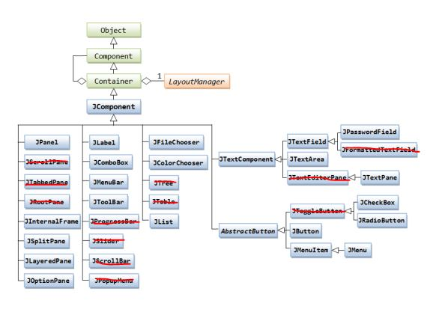
Object
Component
Container
LayoutManager
JComponent
THE
JPasswordField
JPanel
36erol1Pane
JLabel
JFileChooser
JTextField
FormattedTextField
JComboBox
JColor Chooser
TextComponentTextArea
TextEditorPane JTextPane
TabbedPane
JMenuBar
RootPane
JToolBar
3Table
JCheckBox
ToggleButton
InternalFrame ProgressBar JList
JRadioButton
AbstractButton JButton
JSplitPane
JLayeredPane JScrollBar
JOptionPane
JPopupMenu
JMenuItem JMenu

